

1.

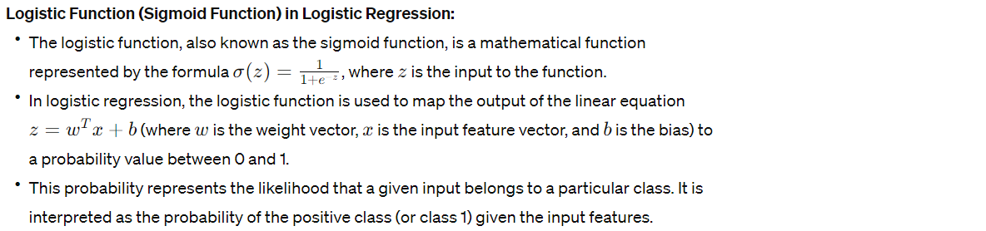

2.

**Criterion for Splitting Nodes in Decision Trees:**

The most commonly used criterion for splitting nodes in decision trees is the "Gini impurity" or "entropy".

Gini impurity measures the likelihood of an incorrect classification if an element from the dataset is randomly labeled according to the distribution of labels in the node.

Entropy, on the other hand, measures the level of impurity or disorder in a group of examples.

The splitting criterion is calculated by computing the weighted sum of impurities or entropy for each possible split and selecting the one that minimizes impurity or entropy after the split.

3.

**Entropy and Information Gain in Decision Tree Construction:**

Entropy is a measure of uncertainty or disorder in a dataset. In the context of decision trees, it represents the impurity of a node.

Information Gain measures the reduction in entropy or impurity achieved by splitting a dataset based on a particular attribute.

Decision trees aim to maximize information gain at each split, meaning they select the attribute that results in the greatest reduction in entropy or impurity.

4.

**Utilization of Bagging and Feature Randomization in Random Forest:**

Random Forest is an ensemble learning method that utilizes bagging (bootstrap aggregation) and feature randomization to improve classification accuracy.

Bagging involves training multiple decision trees on bootstrap samples (random subsets with replacement) of the training data and then averaging their predictions to reduce variance and improve generalization.

Feature randomization involves randomly selecting a subset of features at each node split in each decision tree, which helps decorrelate the trees and reduces overfitting.

5.

**Distance Metric in K-Nearest Neighbors (KNN) Classification:**

The most commonly used distance metric in KNN classification is Euclidean distance.

Euclidean distance measures the straight-line distance between two points in the feature space.

The choice of distance metric can significantly impact the performance of the KNN algorithm, especially when dealing with high-dimensional or non-linearly separable data.

6.

**Naïve-Bayes Assumption of Feature Independence:**

The Naïve-Bayes algorithm assumes that all features are independent of each other given the class label.

This assumption simplifies the calculation of class probabilities by multiplying the conditional probabilities of each feature given the class label.

While this assumption may not hold true in practice, Naïve-Bayes can still perform well in many real-world scenarios and is particularly effective for text classification tasks.

7.

**Role of Kernel Function in SVMs:**

In Support Vector Machines (SVMs), the kernel function is used to map input data into a higher-dimensional feature space where it is easier to find a hyperplane that separates the classes.

The kernel function calculates the dot product between two vectors in the transformed feature space without explicitly computing the transformation.

Commonly used kernel functions include linear kernel, polynomial kernel, Gaussian radial basis function (RBF) kernel, and sigmoid kernel.

8.

**Bias-Variance Tradeoff in Model Complexity and Overfitting:**

The bias-variance tradeoff refers to the balance between bias (error due to overly simplistic assumptions) and variance (error due to sensitivity to small fluctuations in the training data) in machine learning models.

Increasing model complexity (e.g., adding more features or increasing the degree of polynomial in a regression model) tends to decrease bias but increase variance, leading to overfitting.

Conversely, decreasing model complexity tends to increase bias but decrease variance, leading to underfitting.

The goal is to find the right balance between bias and variance to achieve good generalization performance on unseen data.

9.

**Facilitation of Neural Networks Creation and Training in TensorFlow:**

TensorFlow is a popular deep learning framework that facilitates the creation and training of neural networks through its high-level API and computational graph abstraction.

TensorFlow provides various built-in functions and classes for defining and training neural network architectures, including dense layers, convolutional layers, recurrent layers, activation functions, optimizers, and loss functions.

It also offers convenient utilities for data preprocessing, model evaluation, and visualization.

10.

**Cross-Validation and Its Importance in Evaluating Model Performance:**

Cross-validation is a technique used to assess the performance of machine learning models by training and evaluating them on multiple subsets of the dataset.

The dataset is divided into k subsets (folds), and the model is trained k times, each time using k-1 folds for training and the remaining fold for validation.

Cross-validation helps to obtain a more reliable estimate of the model's performance by reducing the variability in performance metrics caused by the random splitting of the data.

11.

**Techniques to Handle Overfitting in Machine Learning Models:**

Some techniques to handle overfitting in machine learning models include:

Regularization: Introducing a penalty term to the loss function to discourage large parameter values and simplify the model.

Cross-validation: Assessing model performance on independent validation data to detect overfitting.

Early stopping: Stopping the training process when the performance on the validation set starts to degrade.

Feature selection: Selecting only the most relevant features to reduce model complexity and overfitting.

12.

**Purpose of Regularization in Machine Learning and How It Works:**

Regularization is a technique used to prevent overfitting by adding a penalty term to the loss function that penalizes large parameter values.

The two most common forms of regularization are L1 regularization (Lasso) and L2 regularization (Ridge).

L1 regularization adds the absolute values of the model parameters to the loss function, encouraging sparsity and feature selection.

L2 regularization adds the squared values of the model parameters to the loss function, encouraging smaller parameter values and smoother models.

13.

**Role of Hyperparameters in Machine Learning Models and Tuning for Optimal Performance:**

Hyperparameters are parameters that are not learned directly from the data but are set before the training process begins.

Examples of hyperparameters include the learning rate, regularization strength, number of hidden layers, number of neurons per layer, etc.

Tuning hyperparameters involves selecting the optimal values that result in the best performance of the model on the validation set.

Techniques for hyperparameter tuning include grid search, random search, Bayesian optimization, and automated hyperparameter tuning libraries.

14.

**Precision, Recall, and Accuracy in Classification Evaluation:**

Precision measures the proportion of true positive predictions among all positive predictions made by the model.

Recall (also known as sensitivity) measures the proportion of true positive predictions among all actual positive instances in the dataset.

Accuracy measures the proportion of correctly classified instances (both true positives and true negatives) among all instances in the dataset.

Precision and recall focus on the performance of the model on positive instances and are useful when the class distribution is imbalanced, while accuracy provides an overall measure of model performance.

15.

**ROC Curve and Its Use in Visualizing Binary Classifier Performance:**

The ROC (Receiver Operating Characteristic) curve is a graphical plot that illustrates the performance of a binary classifier across different threshold settings.

It plots the true positive rate (TPR, also known as sensitivity) against the false positive rate (FPR, also known as 1 - specificity) at various threshold settings.

The area under the ROC curve (AUC) is a commonly used metric to quantify the overall performance of the classifier, with higher AUC values indicating better discrimination ability between the positive and negative classes.

